

Name : Bisma Fatima

Class : CS-24-A

Roll No : F24605036

Course : Object oriented programming

Code : CS-123

Lecturer : Ma’am Tayyaba kalsoom

INLAB TASK
LAB 01

1.Basic concept of input and output : sequential statement , if else, and conditional statement.
PROGRAM
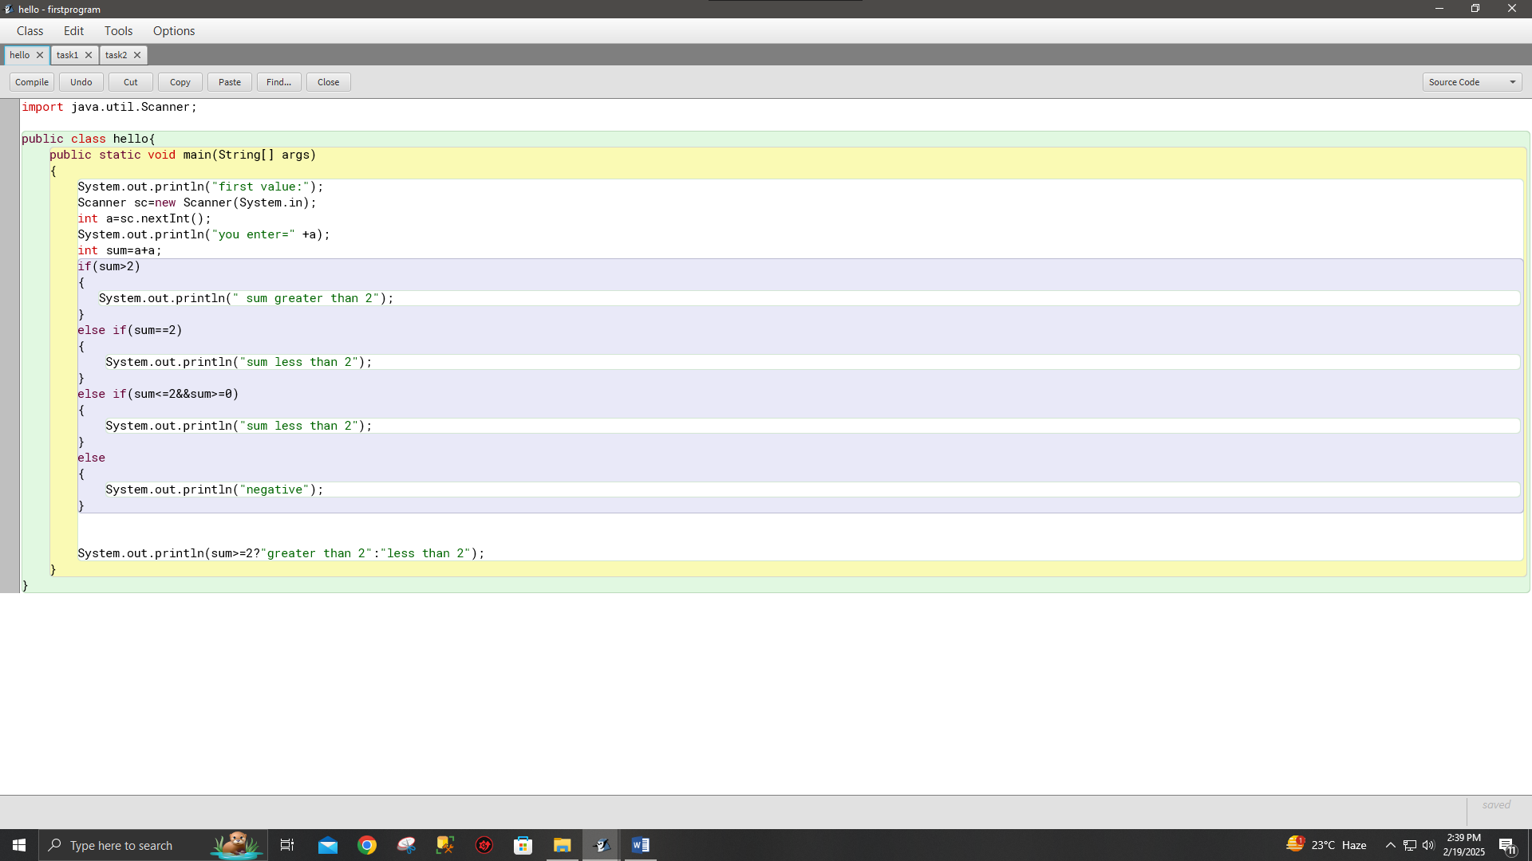
OUTPUT

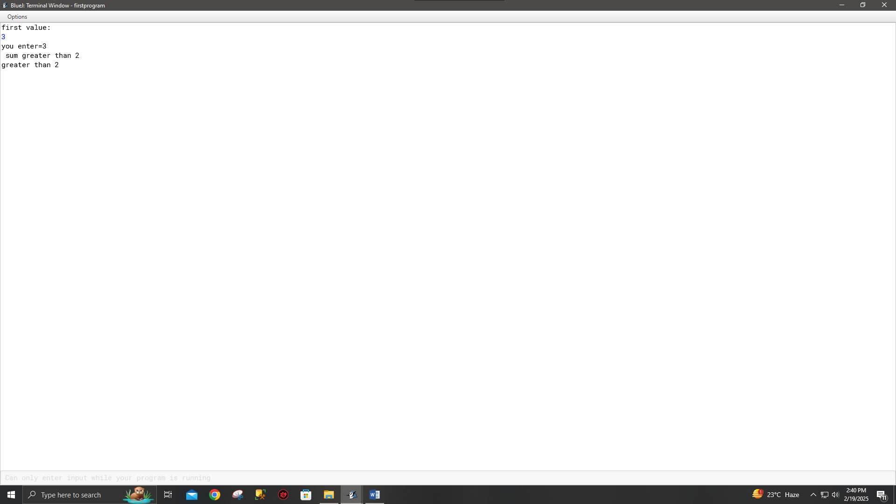
TASK 01
Finding the larger number and print larger value with “is larger”. Using if else statements.

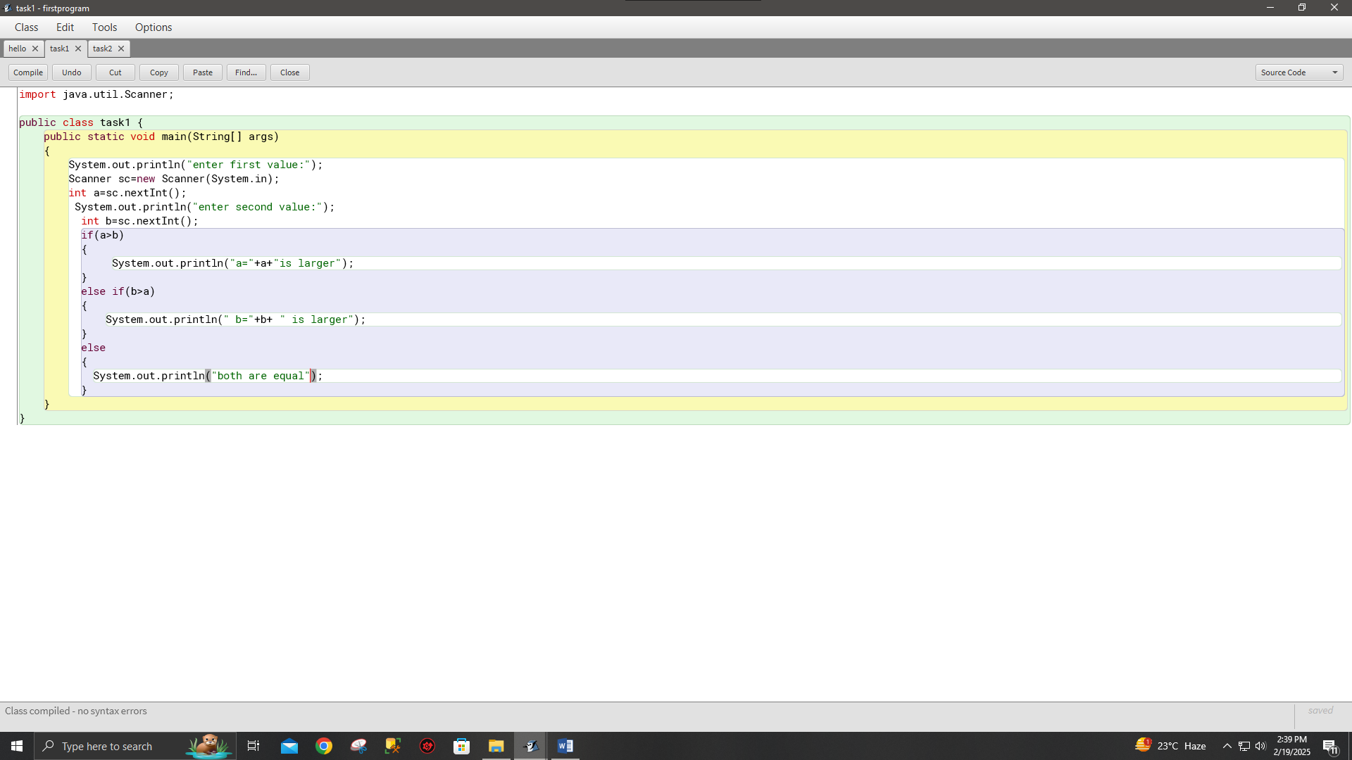
OUTPUT
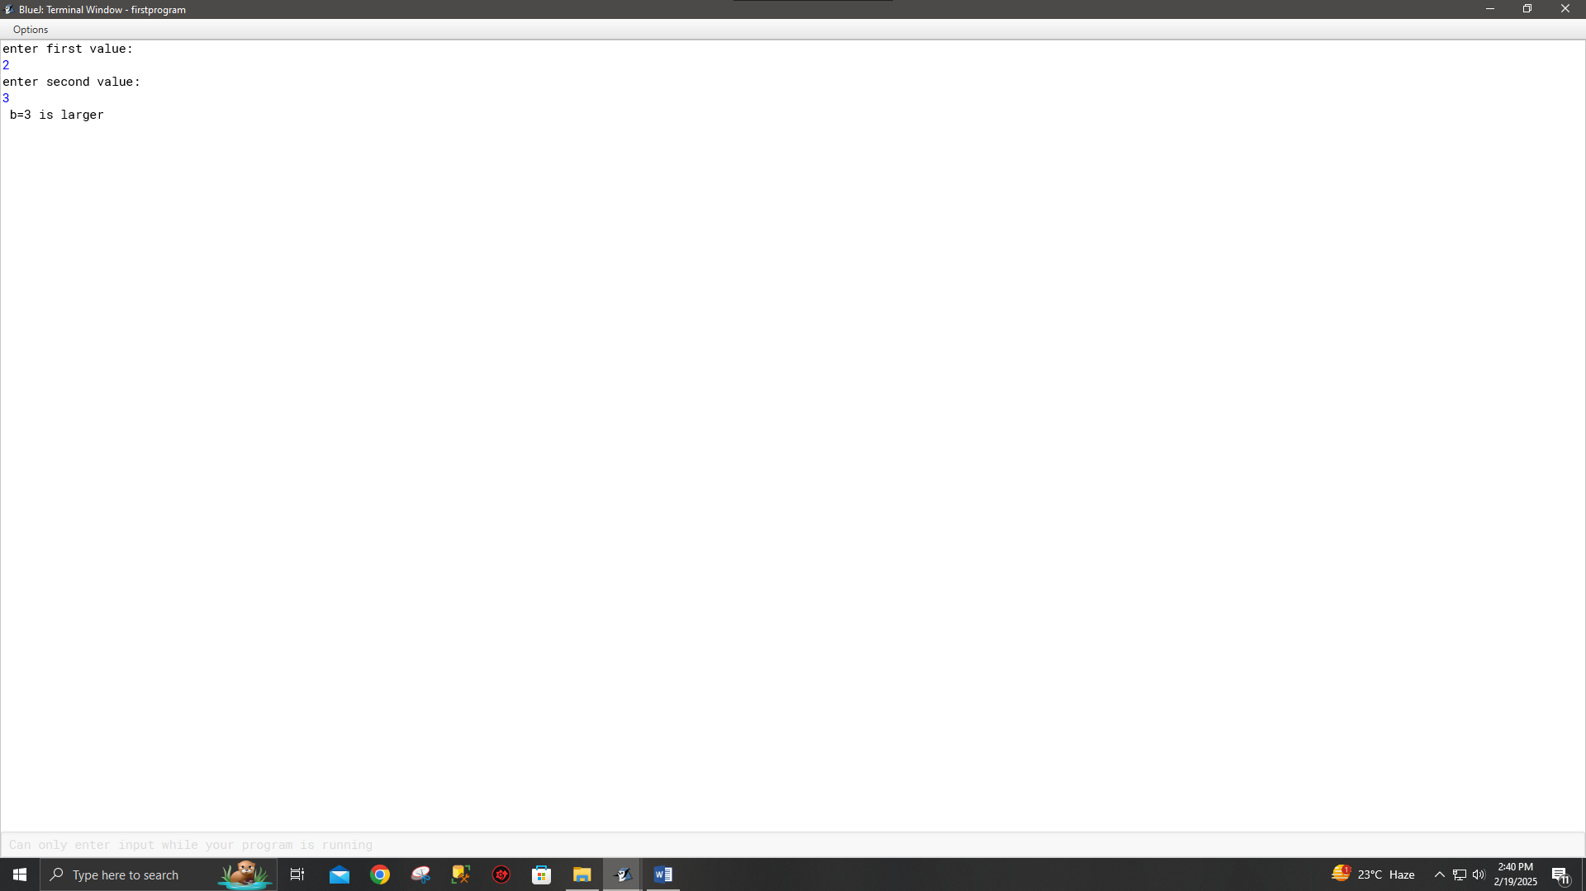

TASK 02
Ask the user to enter the value (1-7) ,and print the day accordingly .
Using switch statement.

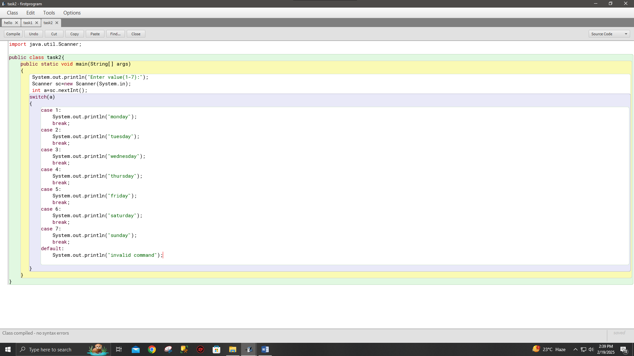

OUTPUT
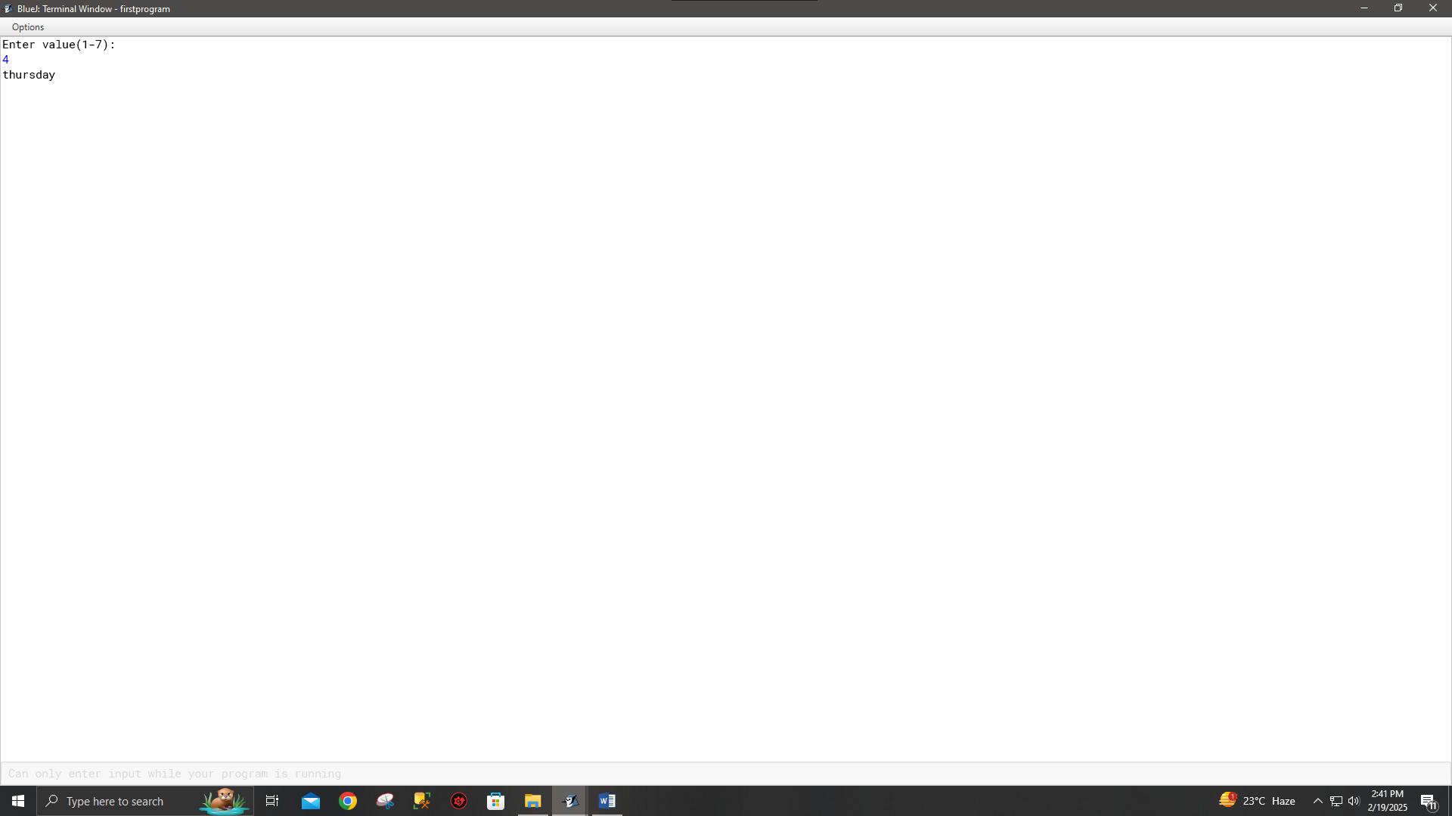

TASK 03
Write a program that take radius from user and calculate diameter , circumference , and area.
Diameter = 2r.
Circumference = 2*pi*r.
Area = pi *r*r.

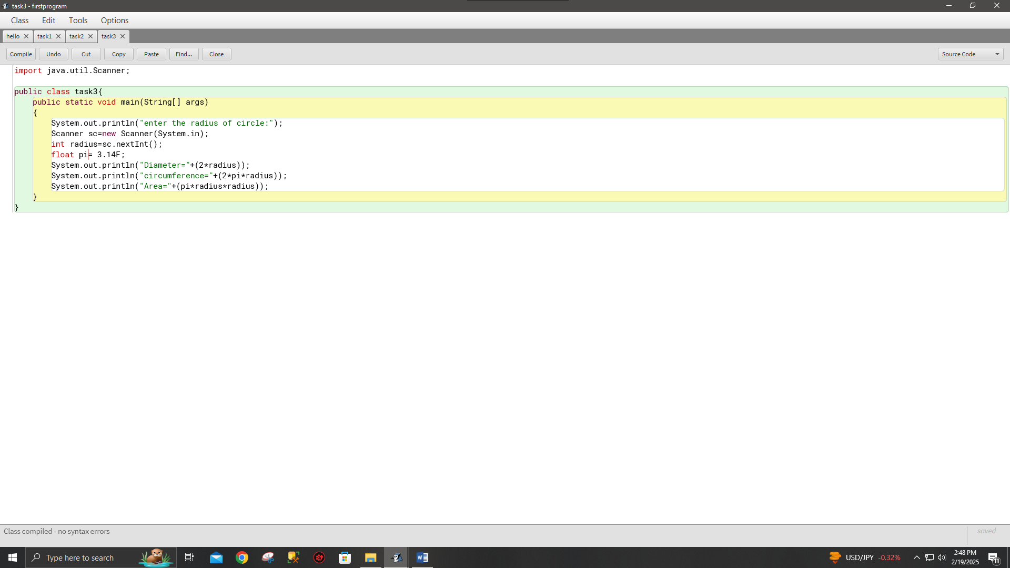
OUTPUT
